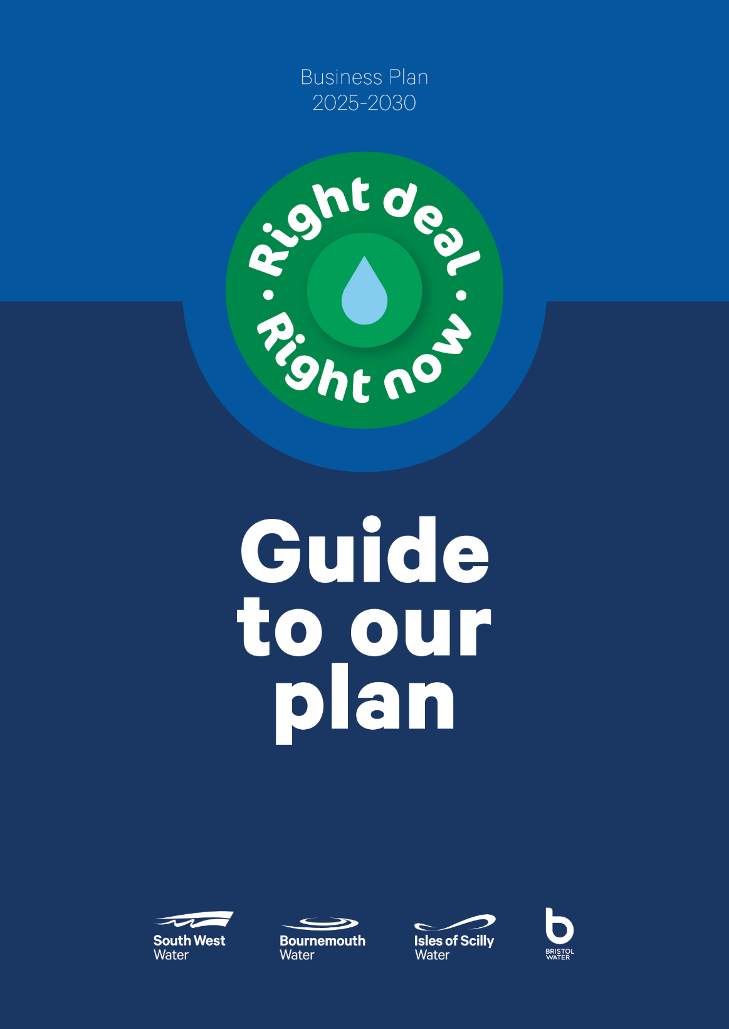

Accounting Separation METHODOLOGY

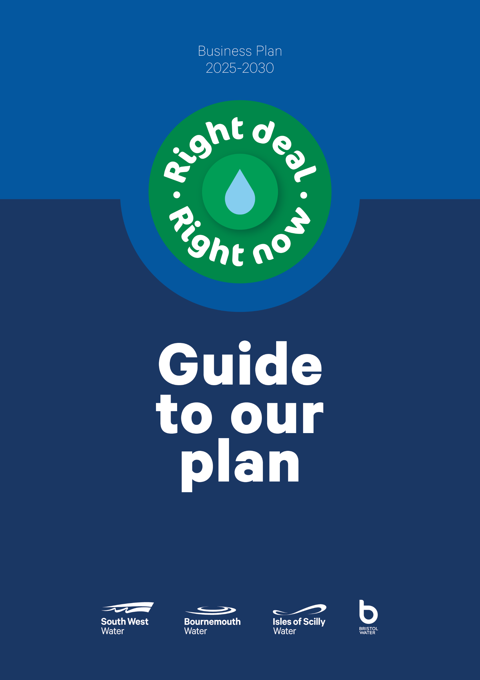

**Contents**

OVERVIEW 2

INFORMATION SOURCES 5

CHANGES TO COST ALLOCATIONS - 2023/24 6

COST ALLOCATION MODEL 7

COST ALLOCATIONS 8

WHOLESALE COST ALLOCATIONS 9

RETAIL COST ALLOCATIONS 18

HOUSEHOLD REVENUES BY CUSTOMER TYPE 21

RETAIL HOUSEHOLD ANALYSIS 22

GROUP SHARED SERVICES COST ALLOCATION 23

CAPITAL MAINTENANCE COSTS 24

CURRENT COST DEPRECIATION CHARGE 25

INFRASTRUCTURE RENEWALS CHARGE 26

RECHARGES BETWEEN BUSINESS UNITS 27

HISTORICAL COST ANALYSIS OF FIXED ASSETS – WHOLESALE & RETAIL 28

APPENDIX A: 29

BUSINESS UNIT, SERVICES, ACTIVITIES AND SUB-ACTIVITIES SUMMARY 29

APPENDIX B: 30

GENERAL LEDGER REPORTING STRUCTURE 30

# OVERVIEW

* 1. The purpose of this report is to explain the procedures undertaken to produce the 31 March 2024 Regulatory Accounting Separation tables – Operating cost analysis, capital expenditure and Fixed Asset analysis for the wholesale and retail business units.
  2. The tables have been prepared in accordance with Regulatory Accounting Guidelines (“RAG’s”) 4.12 effective for the financial year ended 31 March 2024.
  3. The Regulatory Accounts report South West Water’s appointed activities analysed between the ‘Retail’, ‘Clean Water Service’ and ‘Waste Water Service’ business units in respect of the required specific activities and cost categories[1].
  4. Whilst these business units are not treated as organisationally separate businesses or separate companies by South West Water, due to more efficient and effective structures being in place to support the management and accountability of the business, there are certain activities which are solely carried out by specific areas of the business. SWW is gradually modifying its management processes to better reflect the Business Unit reporting requirements.
  5. South West Water Wholesale is currently structured to give separate management structures recognising activities grouped between clean water and waste water, but the activities of many other departments in the company perform functions that provide services across clean water, waste water and retail, and across the business units and activities recognised in the accounting separation tables.
  6. The majority of our customer services activity within the Retail business unit is either:
* Dealt with by Pennon Water Services (a separate company within the Pennon Group) that provides all services to non-household customers, or
* Is contracted out to South West Water Customer Services Limited (“SWWCS”) a wholly owned subsidiary of South West Water. Related general & support overhead is charged from South West Water to Source. These charges are deducted from the contract cost charged by Source to South West Water in determining direct retail costs and separately assessed in line with this methodology for inclusion within general and support expenditure within the other operating expenditure reporting line.
  1. The data hierarchies used in South West Water’s financial systems primarily support the management structure of the Company to support accountability and to most effectively analyse performance against budgets, targets or prior periods. However, the coding used to record financial transactions is designed to also record activity based information to support regulatory accounting, particularly in relation to direct costs.
  2. South West Water does not have a formal activity based costing system, but it does have existing and established processes to allocate operating costs, capital maintenance costs and fixed assets to the separate service areas used to populate the accounting separation tables.
  3. As the business units and services identified in the accounting separation tables are not organisationally separated in South West Water they do not have their own separate management and support functions and they do not trade with one another. To represent them as distinct cost centres and asset centres requires the allocation of costs and assets to them. Where no direct allocation is possible, some subjective judgment is required. The resulting costs reported for these business units do not necessarily represent what the costs would be if they were operated as separate business units.
  4. For direct retail costs, a large proportion of costs are separately identifiable from the SWWCS charges. Allocations are only required between retail activities.
  5. The analysis of direct costs for the wholesale business is essentially obtained from the expense type of the underlying cost (for example employment costs, power, and service charges). These costs are directly identifiable from the way costs are coded in the general ledger. The direct cost analysis for retail contains further division of cost by activity (for example customer service, debt management, meter reading) with the cost being dominated by employment costs for staff who may work across a number of different activities.
  6. The company has extracted the necessary fixed asset information from its existing fixed asset records and has performed validation and re-analysis where it has seen opportunities within these data sources to improve the quality of the information to be entered on the tables.
  7. The responsibility for the compilation of the accounting separation tables and methodologies lies with the Chief Financial Officer of the Pennon Group.
  8. Within South West Water each area of the business is assigned a suitably qualified and experienced Finance Manager to support reporting, analysis and governance. The Managers assigned to the Drinking Water Services and Waste Water Services report to the Head of Business Reporting and Analysis. Those compiling the accounting separation information and data tables liaise with Finance Managers and Functional Managers throughout the business in order to gather and understand data that supports allocations and apportionments and to ensure that appropriate review/ sign-off procedures are in place to support allocations and apportionments.
  9. Final review of the tables is undertaken in conjunction with the relevant Senior Managers.
  10. In preparing the information required for the accounting separation tables the company has developed a cost allocation model as well as adapting, and extending, where necessary, the existing and well-established processes to allocate operating costs, capital expenditure costs and fixed assets to separate service areas.
  11. The company has a well-defined basis for allocating directly related general and support costs, for example vehicles which are allocated to specific individuals’ cost centres. Where there are elements of business support and corporate costs which have no obvious connection to operational activities (and which do not increase or reduce in line with the level of operational activities) business experience has been used to select the most appropriate method of allocation.
  12. The allocation of operating costs within South West Water to specific service areas within the appointed and non-appointed business is based on activity analysis and principles which result in both direct and support costs being apportioned where not directly attributed. Activity levels between individual services between appointed and non-appointed segments are ascertained by reference to time allocations by individual employees along with other allocation basis in accordance to the underlying nature of resource utilisation.
  13. Where such a detailed approach is not applicable, costs are apportioned pro rata to either relevant elements of direct cost or FTE’s for each principal service.
  14. The internal charging rates for operating costs adopted by the company are reviewed for appropriateness both annually and through previous activity based analysis of the overhead and indirect cost base.
  15. The allocation of group shared services costs within South West Water to specific business areas within the appointed and non-appointed business is based upon an assessment of underlying cost drivers according to the nature of resource utilisation. In addition to the direct costs charged to SWW business functions, group wide shared services activities are allocated out to the SWW directorates and business functions by a detailed assessment of the appropriate costs incurred by the individual business functions.
  16. Where there are elements of business support and corporate costs which have no obvious connection to operational activities (and which do not necessarily increase or decrease in line with the level of operational activities) judgement has been used to select the most appropriate method of allocation, for example FTE’s.
  17. In developing a methodology to complete the accounting separation tables the company’s cost allocation model (first used in 2012/13 and modified in 2013/14) has been used for the year ended 31 March 2024 to aid reporting and analysis of data. This forms the backbone to producing the regulatory accounts and enables the separate business unit and subsequent service analysis to be more easily obtained.
  18. Cost and asset allocations have been made in a transparent, objective and non-discriminatory manner, ensuring the underlying causality of the cost is reflected. Allocations are made on a consistent basis, subject to improvements made to allocation methodologies and underlying data sources. Operating costs have been allocated by specific general ledger line and assets by individual asset, reflecting the highest possible level of granularity. These attributes, along with clear and well documented procedure / methodology significantly aid management review and assessment of cost and asset allocations to ensure all allocations to services and business units are reasonable.
  19. A more detailed description of the general ledger (“GL”) coding system is detailed in Appendix B.

# INFORMATION SOURCES

* 1. Cost Information is derived from Ellipse, the company’s general ledger system, which is aligned to International Financial Reporting Standards (IFRS). A full general ledger profit and loss account download is extracted from Ellipse and entered into the Accounting Separation cost allocation Excel model.

* 1. A fixed assets register (Real Asset Management – “RAM”) is used to record the detail of fixed assets and related depreciation charges for the historical cost regulatory accounts.
  2. Current cost accounts information, including fixed asset values and depreciation charges, is not processed through Ellipse but controlled through a separate current cost fixed assets register. This includes the full data from the March 2008 MEA (modern equivalent asset) Revaluation and all non-infrastructure additions since 1 April 2008. The register has been used as the source for the current cost depreciation charge. Other CCA values including gross book values which include an allocation of capital WIP and relevant indexation are based on relevant capital expenditure for which there is a detailed analysis using data from the Ellipse project costing system.

# CHANGES TO COST ALLOCATIONS - 2023/24

* 1. The basis for allocating South West Water costs between business units has remained unchanged during 2023/24.
  2. The allocation of the central costs to SWW and to business functions within South West Water follows OFWAT Regulatory Accounting Guidelines as set out in 4.12.
  3. SWW has exited the non-household (NHH) market, although SWW has continued to assist in the delivery of some NHH activities (developer services, initial operation contacts and third party services), in accordance with Ofwat guidance, 100% of these costs have been allocated to Wholesale.

# COST ALLOCATION MODEL

* 1. The figure below shows the methodology of the cost allocation model to business unit level.



The flow chart shows that whilst allocations are required as outlined in sections of the methodology the starting point of information for the accounting separation tables is the South West Water general ledger.

The flow chart also clearly identifies the hierarchy used for attributing costs to the business unit level of the accounting separation tables.

Further metrics are then applied to business unit costs to provide an allocation to service level (within business units) as explained later in this document.

# COST ALLOCATIONS

* 1. For 2023/24 the revised general ledger balances have been allocated to the Services and Activities in the OFWAT using the same percentages as used in 2022/23, based on the full General Ledger posting accounts.
  2. Where costs are not wholly attributed to a specific service area, costs are allocated between service areas based on an underlying assessment of the costs and their respective drivers by management. The approach is consistent with the basis of allocation within each service area. The cost driver metrics used in 2022/23 have been reviewed and where necessary updated for 2023/24.

# WHOLESALE COST ALLOCATIONS

* 1. Following publication of the updated Regulatory Accounting Guidelines (RAGs), version 4.12, and confirmation of two new price controls wholesale cost allocations have been reviewed and updated as required.
  2. The process of cost allocation for the Wholesale tables is explained below:
  3. Wholesale costs are initially allocated between four prices controls before then being allocated to eight business units. The final step in the process is to then allocate costs to services. The table below shows the link between each of the allocation levels:

|  |  |  |
| --- | --- | --- |
| Price Control | Business Unit | Service |
| Water Resources | Water Resources | Abstraction Licences |
| Raw Water Abstraction |
| Water Network+ | Raw Water Transport | Raw Water Transport |
| Raw Water Storage | Raw Water Storage |
| Water Treatment | Water Treatment |
| Treated Water Distribution | Treated Water Distribution |
| Wastewater Network+ | Sewage Collection | Foul |
| Surface Water Drainage |
| Highway Drainage |
| Sewage Treatment | Sewage Treatment and Disposal |
| Imported Sludge Liquor Treatment |
| Bioresources | Sludge | Sludge Transport |
| Sludge Treatment |
| Sludge Disposal |

Note: South West Water exited the Non-household retail market on 1 April 2017. Following this date there are no associated retail costs in the non-household price control. These have been allocated to the Wholesale sector.

***Allocation to Price Controls and Business Units***

* 1. The RAG definitions for wholesale activities were reviewed and used to identify and apply direct cost allocations to specific business units for costs that are separately identifiable from the Ellipse general ledger coding system. For example the cost of water or sewerage treatment works.
  2. In other cases, whilst costs are readily identified from the Ellipse general ledger, they are not directly attributable to one particular business unit. Where this is the case, the most appropriate form of apportionment or allocation is identified, by the appropriate Management team, and applied to the cost centre.
  3. The table below lists the operating expenditure lines included within total wholesale operating expenditure and outlines the sources of the cost contained within each line and where apportionments have been used:

| **Operating Expenditure heading** | **Costs included and method of allocation** |
| --- | --- |
| Power | All energy costs  Power costs are allocated to individual sites which are in turn allocated to specific business units.  At combined sites an allocation of the power costs is determined based on an assessment of the power usage of individual items of equipment. |
| Income treated as a negative expense | Income received from energy generation.  Energy generation income is allocated to sites which are in turn allocated to specific business units.  Income received from solar and wind power generation installed prior to the 2015/16 financial year is classified as non-appointed income and is excluded from the accounting separation tables. |
| Abstraction charges / discharge consents | Total cost of charges by the Environment Agency or the Canal & River Trust for water abstraction and discharge consents.  Allocation to business unit is made through reference to the individual cost centres charges are posted against. |
| Bulk supply imports | Total payments for bulk imports/exports.  South West Water does not rely on bulk imports and sources all water from resources within the South West Water operating area. |
| Renewals expensed in year (Infrastructure) | Infrastructure renewals which are expensed rather than capitalised in the statutory accounts.  Refers to expenditure capitalised under the UKGAAP accounting but classified as an operating cost under IFRS. Costs are also referred to as opex transfers.  Expenditure is incurred on the sewerage collection and treated water distribution business units only and is allocated accordingly. |
| Renewals expensed in year (non-infrastructure) | Non-Infrastructure renewals which are expensed rather than capitalised in the statutory accounts.  Currently all SWW non infrastructure renewals are capitalised. |
| Other operating expenditure | All other operating costs.  Allocated to business units based on the underlying cost driver of the specific cost.  Where possible other operating expenditure is allocated directly to business units. Where direct allocation is not possible management assessment is used to allocate the costs.  Corporate and support costs are allocated to business units using the most appropriate underlying cost driver. Where costs cannot be specifically allocated costs are apportioned pro-rata to direct or total cost. |
| Local authority rates | The cost of local authority rates (including cumulo rates and sewage site rates).  Water Cumulo are allocated on the basis of MEAV (Modern Equivalent Asset Value).  Sewerage rates allocated direct to sites via local authority bill. At combined sewage and sludge treatment centres rates are apportioned on MEAV.  Local authority rates for support buildings are apportioned between functions by floor area. |
| Third Party Services – Operating Expenditure | Operating expenditure relating to providing third party services.  Allocated to business unit based on the underlying cost driver of the specific cost. Where possible third party services costs are allocated directly to a business unit. Where direct allocation is not possible management assessment is used to allocate the costs. |

* 1. Wholesale direct cost allocations are initiated by a combination of the cost centre, process code and expense element of Ellipse.
* Cost centre

Initial allocation of a cost centre to a business unit is based on the nature of the cost centre. The subjective analysis category is driven by the cost centre. Where the subjective analysis category matches a business unit description an allocation to that specific business unit is made. For example, “Water Treatment” subjective analysis category is allocated to the Water Treatment business unit.

* Process code

Certain activities performed by South West Water can be identified through the process code for example A95 Abstraction charges. Allocations of certain costs to business units are made based on these codes.

Based on the process codes, costs might be reallocated from the business unit to which the cost would have been allocated if only the cost centre and subjective analysis category was used for allocation.

* Expense element

The accounting separation tables require the wholesale costs to be disclosed by the expense types listed in the table above

Costs are allocated to each of these cost types using the expense element. For example expense element “Power” on a cost centre with a subjective analysis category of “Water Treatment” is allocated to the power cost type in the water treatment business unit: Water Treatment – Power.

* 1. Where cost allocations span the boundary between business units management assessment is required to allocate the cost.

Scientific Services

* 1. The entire total cost of scientific services has been allocated to the wholesale business units, covering the cost of sampling including sampling at customer taps, quality monitoring, testing, performance monitoring etc. Sampling and quality monitoring costs are managed on a regional basis and allocated to business units based on the specific activities undertaken within each region by way of management assessment.
  2. Laboratory costs are allocated to business units based on the number of tests performed, whilst support costs including performance monitoring and senior managers’ time has been allocated based on management assessment.

Wholesale Manual Adjustments

* 1. Due to the current data hierarchies used by South West Water being primarily in place to support the management structures of the Company certain costs allocated based on cost centre, process code and expense element require manual adjustment in order to allocate the costs to the appropriate, Ofwat defined, business unit.
  2. The manual adjustments are processed within Excel in a separate adjustments model. This model utilises data contained within the GL, equipment register, chemical purchasing system together with management and specialist assessments of cost allocation (e.g. manpower allocations, power assessments, etc) to determine the adjustments required to the business unit cost allocations.
  3. Once calculated the manual adjustments are imported back into the main model to adjust the business unit cost allocations to better reflect the underlying cost drivers.
  4. The table below lists the manual adjustments made and outlines the source of information and methodology behind each adjustment.

| **No.** | **Adjustment** | **Information source and methodology** |
| --- | --- | --- |
| 1 | Re-allocation of Chemical costs from Sewage Treatment to Sludge Treatment | Chemical costs are captured by cost centre and therefore chemical spend at Sludge Treatment Centre (“STCs”) is allocated directly to the Sewage Treatment business unit.  A reallocation of chemical cost in completed using purchasing information abstracted from ChemBase. |
| 2 | Re-allocation of Maintenance costs from Sewage Treatment to Sludge Treatment | Maintenance costs are captured by location and, based on the cost centre allocated directly to Sewage Treatment at the STCs.  Using the equipment number this adjustment re-allocates the maintenance cost of Sludge Treatment equipment from Sewage Treatment to Sludge Treatment. |
| 3 | Re-allocation of Manpower costs from Sewage Treatment to Sludge Treatment | Manpower costs are captured by cost centre and therefore the allocation of manpower costs at STCs is allocated directly to Sewage Treatment.  Man-hour allocations between Sewage Treatment and Sludge Treatment are used to re-allocate manpower costs from Sewage Treatment to Sludge Treatment. |
| 4 | Re-allocation of Power from Sewage Treatment to Sludge Treatment | Power costs are captured by cost centre and therefore spend at STC’s is allocated directly to Sewage Treatment.  Costs are reallocated to sludge treatment based on asset information collated by operational experts and power assessments performed by the SWW energy team. |
| 5 | Re-allocation of other costs from Sewage Treatment to Sludge Treatment | This adjustment is to re-allocate other costs allocated directly to Sewage Treatment to Sludge Treatment that have not been re-allocated by the adjustments above. |
| 6 | Calculation of imported sludge liquor costs. | Under the revised RAGs the costs of treating liquor returned from the sludge treatment process are to be reported separately.  Treating return liquor requires additional oxygen to be pumped into the treatment process as a result of the high Biological Oxygen Demand (BOD) of the liquor. This adjustment therefore re-allocates power costs based on the ratio of BOD treated.  We have also included an element of Maintenance costs by looking at secondary and tertiary equipment maintenance spend and using the BOD % on those sites to apportion the maintenance costs to sludge liquor treatment. |
| 8 | Re-allocation of power and operating costs from to sludge treatment to water treatment | The cost of treating all sludge is posted in the general ledger to sewage treatment site cost centres, which in turn are allocated between sewage and sludge treatment. However, there is an element of clean water sludge that is processed at sewage treatment sites which requires allocating to water treatment. |
| 9 | Allocation of  tankered waste costs to Non-appointed activities | The treatment of Tankered Waste is deemed to be a non-appointed activity. The costs of treating tankered waste are captured within the Sewage Treatment and Sludge Treatment business units.  Removal of costs from waste water for inclusion with non-appointed activities is mainly based on the ratio of BOD of tankered waste to total BOD treated. We have also included all of the commercial team costs, cost of running the JRP system, licence fees, WW management time and training costs in running the technically competent manager programme, and a percentage of sales ledger’s time, based on the level of billing. |
|  |  |  |

* 1. The analysis of corporate and support costs specifically identifies any direct costs that can be directly attributable to wholesale business units. Other non-direct corporate and support expenditure allocated to wholesale is included within other operating expenditure.

**Allocation of Clean Water Business Units to Services**

TheClean Water Business Units break down into services as shown in section 6.3

* 1. **Water Resources**

The Water Resources business unit consists of two Services, Abstraction Licences and Raw Water Abstraction

* 1. **Abstraction Licenses**

The costs of abstraction licences are separately identifiable within the Water Resources business unit as “Service Charges”. The costs of the abstraction licences are allocated to the abstraction licence service. In addition an allocation of costs relating to negotiating with third parties to obtain the abstraction rights and agree charges is allocated to the abstraction licence service.

The negotiation of abstraction licences with third parties within South West Water is performed by the Drinking Water Supply Demand Strategy Team. Management assessment is used to determine the amount of time spent on negotiating abstraction licences by this team.

* 1. **Raw Water Abstraction**

Following the allocation of costs to the abstraction licence service the balance of the Water Resources business unit cost is allocated to the raw water abstraction service.

* 1. **Raw Water Distribution**

The Raw Water Distribution business unit consists of two services, Raw Water Transport and Raw Water Storage.

* 1. **Raw Water Transport**

After deducting the cost of Raw Water Storage, the balance of the Raw Water Distribution business unit is allocated to the Raw Water Transport Service.

* 1. **Raw Water Storage**

The geography and topography of the South West Water region results in relatively short distances between water resources and water treatment works. Raw water can be transported directly from the abstraction point to water treatment works. As a result there is a very limited requirement to store raw water. Break tanks which are used to reduce head (pressure) on spine mains have been allocated to raw water transport, and not raw water storage, as their sole purpose is to control the pressure on the network and not store raw water.

* 1. **Water Treatment**

The Water Treatment Business Unit contains only one service. All costs identified as being part of the Water Treatment Business Unit by the Accounting Separation Methodology are allocated to this Service.

* 1. **Treated Water Distribution**

The Treated Water Distribution business unit contains only one service. All costs identified as being part of the Treated Water Distribution business unit by the Accounting Separation Methodology are allocated to this service.

Allocation of Waste Water Business Units to Services

The Waste Water Business Units break down into 8 Services as shown in section 6.3

* 1. **Sewage Collection**

The operating cost of the Sewage Collection Business Unit is identified by the Accounting Separation Methodology. The business unit cost is allocated to services based on the length of each type of sewer as recorded in South West Water’s Geographic Information System (“GIS”).

|  |  |  |  |
| --- | --- | --- | --- |
|  |  | Total Length (Km) | **%** |
| Sewage Collection | Highway Drainage | 476 | 4.0% |
| Surface Water Drainage | 2660 | 22.5% |
| Foul (Combined) | 8679 | 73.5% |
| Total | 11815 | 100 |

A proportion of South West Water’s sewage collection network is combined (i.e. it is used to collect foul, surface drainage and highway drainage).

* 1. **Sewage Treatment and Disposal**

The cost for the Sewage Treatment business unit is identified as part of South West Water’s accounting separation process. This is allocated 100% to the Sewage Treatment and Disposal service.

* 1. **Imported Liquor Treatment**

Under the RAGs the costs of treating imported liquors are classified as a sewage treatment cost. Treating sludge liquor requires additional oxygen to be pumped into the treatment process as a result of the high Biological Oxygen Demand (BOD) of the liquor. For each of the 28 Sludge Treatment Centres the volume and BOD strength of the return liquor as a percentage of the total BOD load for the sewage treatment works is calculated. This ratio is applied to the power cost for the sewage treatment works to derive the power cost of sludge liquor treatment.

Additionally the maintenance cost for the secondary and tertiary treatment equipment at the sewage treatment works is identified and the liquor BOD ratio is applied to this cost to derive the additional maintenance costs of sludge liquor treatment.  This is small compared to the power cost.

After allocating direct costs, an apportionment of the sewage treatment share of central overhead costs is allocated to liquor treatment pro rata to direct cost.

* 1. **Sludge**

The cost of Sludge Transport, Sludge Treatment and Sludge Disposal are each separately identifiable.

* 1. **Sludge Transport**

Sludge Transport costs are the costs of transporting sludge from satellite sewage treatment works to one of South West Waters 28 sludge treatment centres. These movements are known as interworks. All interworks costs are separately identifiable within the general ledger by expense element and thus allocated to the sludge transport service.

After allocating direct costs, an apportionment of the sludge treatment share of central overhead costs is allocated to Sludge Transport pro rata to direct cost.

* 1. **Sludge Treatment**

Sludge Treatment is identified as the cost of treating indigenous and imported sludges at the Company’s 28 sludge treatment centres, each of which is co-located with a sewage treatment works. The separation of Sewage Treatment cost from Sludge Treatment cost at these 28 sites is partly by management assessment and partly by direct cost allocation as described in section 6.14.

* 1. **Sludge Disposal**

Sludge disposal costs are the costs of disposing of sludge from the sludge treatment centres. This process is carried out by a single contract and the cost is separately identifiable in the General Ledger by expense element.

# RETAIL COST ALLOCATIONS

* 1. SWW have exited the non-household (NHH) market, although SWW has continued to assist in the delivery of some NHH activities (developer services, initial operation contacts and third party services) in accordance with Ofwat guidance 100% of these costs have been allocated to Wholesale.
  2. The RAG definitions for retail activities were reviewed and used to identify and apply direct cost allocations to costs that are separately identifiable from the general ledger coding system e.g. meter reading costs, bad debt expense, etc.
  3. In other cases, whilst costs are readily identified from the general ledger, they are not directly attributable to one particular activity line within the retail unit. Where this is the case, the most appropriate form of apportionment or allocation is identified, by the appropriate Management team, and applied to the cost centre.
  4. The table below lists the retail activities included within retail total operating expenditure and outlines the sources of the cost contained within each line and where apportionments have been used.

| **Operating Expenditure Activity** | **Costs included and method of allocation** |
| --- | --- |
| Customer Services | This represents the costs associated with Billing, Payment Handling, remittance and cash handling, Charitable Trust donations, Vulnerable customer schemes, Non-Network customer enquiries and complaints, Network Customer enquiries and complaints.  The majority of customer services cost is directly allocated from the contract cost of Source Contact Management Limited based on an assessment of time spent on specific customer services activities. |
| Debt Management | Includes all costs relating to the management of debt recovery, including monitoring debt, issuing reminders and undertaking follow up calls. Managing external debt collection routes and notification of disconnection to non-households.  The majority of debt management cost is directly allocated from the contract cost of Source Contact Management Limited based on an assessment of time spent on specific debt management activities. |
| Doubtful debts | Relates to the charge for bad and doubtful debts.  The total charges are identified from the general ledger |
| Meter Reading | Includes all costs associated with meter reading including supervising and managing meter readers.  The cost of meter readers is specifically identified from the general ledger. The cost of service delivery managers in managing meter reading activities is allocated from specific cost centres in the general ledger based on a time assessment. |
| Services to Developers | Represents the cost of providing developer services including:   * Providing developer information, dealing with questions from developers where physical aspects of infrastructure are required to change. Investigating and advising on implications and; * Administration of new connections   Cost are specifically identified from the general ledger and wholly attributed to wholesale. |
| Other operating expenditure | Other operating expenditure, excluding interest and tax, includes:   * Decision and administration of disconnections and reconnections * Demand-side water efficiency initiatives * Customer side leaks * Other direct costs * General & support costs * Other business activities   Cost centres relating to the above activities are either directly identified and allocated from the general ledger or apportioned based on a specific time assessment or the most appropriate underlying cost driver.  Other direct costs principally comprise customer policy and relations costs. |
| Rates | Represent the cost of local authority business rates. No other type of rates is included within Retail costs. All Cumulo rates have been allocated to the wholesale water business due to all retail employees being based at sites that pay local authority business rates. This is consistent with the approach taken in the prior year.  Local authority rates for support buildings are apportioned between functions by floor area. |
| Exceptional items | Exceptional items as defined by IFRS. |
| Third Party Services | Comprises the cost of providing retail services to third parties. The cost has been allocated based on a time assessment and directly attributed to wholesale. |
| Debt written-off | Represents debt written-off, net of recoveries of debts previously written-off.  Cost has been directly attributed. |

* 1. A significant proportion of retail costs relate to work undertaken by Pennon Water Services Limited (PWS) and South West Water Customer Services Limited (SWWCS).  PWS is a separate company within the Pennon Group set up to manage all the customer relationships with non-household customers (including collection risk) whilst SWWCS is contracted to undertake customer contact and account activities for household customers on behalf of South West Water, including billing (although the risk of collection remains with South West Water). The cost of the PWS and of the SWWCS contract (less amounts charged to Source for corporate services) have been directly allocated to retail activities in accordance with the cost drivers set out in the Ofwat guidelines based on a detailed analysis, by the management teams, of the activities carried out during the year.  The analysis includes an allocation of costs of contacting customers via outbound calls allocated to the retail activity to which it relates.
  2. No bills are issued to “the occupier”. Where a customer has vacated a property leaving amounts unpaid full provision is made against the outstanding debt, no credit notes are issued to cancel all or part of the outstanding debt.
  3. The doubtful debt charge represents the movement in the doubtful debt provision, which reflects the company’s assessment of the risk of non-recoverability of debt. The provision is calculated by applying expected recovery rates to debts outstanding at the end of the accounting period.  These recovery rates take into account the stage in the recovery process, payment history and type of debt. Higher provisioning percentages are applied to categories of debt which are considered to be of greater risk, including those with a poor payment history.  Doubtful debt provisioning rates are updated annually to reflect the latest collection performance data from the company’s billing system.
  4. Corporate and support costs separately identify directly attributable costs that can be allocated to specific retail activity, for example the costs of the Rapid billing system have been allocated directly to the billing activity within the retail business unit. Other corporate and support expenditure which cannot be directly allocated to a specific retail activity or specific disclosure line are included within other operating expenditure.
  5. Retail costs are directly attributed to households. Costs which are not directly attributed are allocated to household based on an assessment of the most appropriate underlying cost driver (eg bill numbers, customer contacts etc).

# HOUSEHOLD REVENUES BY CUSTOMER TYPE

* 1. **Unmeasured Water Only Customers**

Wholesale and retail revenues are calculated based on a detailed outturn calculation consistent with the SWW tariff model for 2023/24 based on tariffs values, meter and property numbers and rateable values. Customer numbers are consistent with this detailed outturn calculation.

* 1. **Unmeasured Wastewater Only Customers**

Wholesale and retail revenues are calculated based on a detailed outturn calculation consistent with the SWW tariff model for 2023/24 based on tariffs values, meter and property numbers and rateable values. Customer numbers are consistent with this detailed outturn calculation.

* 1. **Unmeasured Water and Wastewater Customers**

Wholesale and retail revenues are calculated based the sum of unmeasured water and wastewater revenues in 2023/24 minus unmeasured water only and wastewater only revenues. Customer numbers are consistent with outturn figures in the SWW tariff model for 2023/24

* 1. **Measured Water Only Customers**

Wholesale and retail revenues are calculated based on a detailed outturn calculation consistent with the SWW tariff model for 2023/24 based on tariffs values, meter and property numbers and volumes. Customer numbers are consistent with this detailed outturn calculation.

* 1. **Measured Wastewater Only Customers**

Wholesale and retail revenues are calculated based on a detailed outturn calculation consistent with the SWW tariff model for 2023/24 based on tariffs values, meter and property numbers and volumes. Customer numbers are consistent with this detailed outturn calculation.

* 1. **Measured Water and Wastewater Customers**

Wholesale and retail revenues are calculated based the sum of measured water and wastewater revenues in 2023/24 minus measured water only and wastewater only revenues. Customer numbers are consistent with outturn figures in the SWW tariff model for 2023/24

# RETAIL HOUSEHOLD ANALYSIS

* 1. The retail household costs obtained from table 2c are analysed between measured and unmeasured customers and, within each of these categories, across customers receiving water only service, sewerage only service or water & sewerage service.
  2. To populate this table, the total household costs have been allocated to the appropriate category based on the number of customers receiving the service as a proportion of the overall customer numbers, as reported in table 2f.
  3. Demand side efficiency and Customer-side leak repairs represent the apportionment of costs from a number of Retail cost centres, based on management assessment.

# GROUP SHARED SERVICES COST ALLOCATION

* 1. The allocation of group shared services costs within South West Water to specific business areas within the appointed and non-appointed business is based upon an assessment of underlying cost drivers according to the nature of resource utilisation.
  2. The company has a well-defined basis for allocating certain directly related support costs, such as vehicles and HR costs which are allocated on the following basis:

|  |  |
| --- | --- |
| **Cost** | **Allocation basis** |
| Transport, vehicles & plant | Directly attributable based on usage |
| Human Resources (HR) | FTE’s |

* 1. In addition to the direct costs charged to SWW business functions, group wide shared services activities are allocated out to the SWW directorates and business functions by a detailed assessment of the appropriate costs incurred by the individual business functions.
  2. Where there are elements of business support and corporate costs which have no obvious connection to operational activities (and which do not necessarily increase or decrease in line with the level of operational activities) judgement has been used to select the most appropriate method of allocation, for example FTE’s.
  3. Where support costs are not specifically allocated they are apportioned pro rata to the relevant elements of direct or total cost for each business area (including non-appointed) subject to management assessment of the effect of direct costs.

# CAPITAL MAINTENANCE COSTS

* 1. Capital maintenance costs, relating only to the wholesale business, are reported in tables 4J and 4K. The value is the full current cost depreciation (CCD) charge plus the estimated Infrastructure Renewals Charge (IRC) with limited deductions for non-infrastructure grant amortisation and recharges.
  2. Current cost depreciation is as calculated in the RAM CCA fixed assets register. In accordance with recently updated Ofwat guidance, where assets are the subject of allocations between wholesale and retail activities, or between those activities and non-appointed activities, depreciation is allocated to the principal activity and any reallocation of depreciation costs is treated as a recharge between segments (Table 2A). All relevant depreciation has accordingly been treated as wholesale depreciation.
  3. The values exclude CCA depreciation charged in 2023/24 on interest capitalised in 2022/23, in accordance with Ofwat’s instructions. This asset has been excluded from the CCA register values.

# CURRENT COST DEPRECIATION CHARGE

* 1. Depreciation is not usually charged by the company on capital work in progress (WIP) balances as these balances mainly relate to incomplete projects for which no depreciation is appropriate.
  2. Depreciation is calculated on a monthly basis.
  3. Depreciation charged on assets added to the CCA register during the year is identical to the historical cost accounting (HCA) charge as no indexation is applied in the first year.
  4. No depreciation is charged on infrastructure assets. The equivalent cost for these assets is the infrastructure renewals charge included as part of the current cost capital maintenance charges.
  5. No assets are owned which are principally used in the provision of third party services so no deduction is required from current cost depreciation in respect of third party services.

# INFRASTRUCTURE RENEWALS CHARGE

* 1. The infrastructure renewals charge (IRC) is only allocated to business units with infrastructure fixed assets allocated to them i.e.
* Water resources
* Raw water distribution
* Treated water distribution
* Sewage collection
* Sewage treatment (in relation to outfalls)
  1. The IRC for treated water distribution and sewage collection is calculated by reference to the K5 asset management plan which looked at five years’ historical spend and ten years’ future projected spend. The difference between IRE (Infrastructure Renewals Expenditure) and IRC was treated as an accrual or prepayment but following the K6 changes to Regulatory Accounts requirements has been deducted from reserves.

* 1. The infrastructure renewals charge automatically reflects current costs as the calculation is a prospective one which reflects current costs.

# RECHARGES BETWEEN BUSINESS UNITS

* 1. Where possible assets have been allocated directly to the business unit to which they relate. Assets which are utilised by more than one business unit have been allocated on the following basis:

|  |  |
| --- | --- |
| **Asset** | **Allocation** |
| Direct assets utilised by one business unit | Asset recorded in business unit |
| Direct assets used by more than one wholesale business unit | Asset is allocated between the wholesale business units that used the asset based on usage |
| Direct assets used by both wholesale and retail business units | Asset is allocated between the wholesale business units that used the asset based on usage with a recharge to the relevant retail business units |
| General and support assets where part of the asset can be directly identified as being a principally retail (or wholesale) asset | The relevant assets are allocated to the relevant business units. Recharges have not been necessary for these assets which include retail IS software. |
| General and support assets | All the relevant assets are principally used in the wholesale business and have been allocated to relevant wholesale business units with a recharge of depreciation to retail and non-appointed business units. |

* 1. For the year ended 31 March 2023 all assets in respect of which part of the depreciation has been recharged have been reported as wholesale assets in accordance with the OFWAT guidance. The recharges, calculated on the historical cost basis, are reported at the bottom of Table 2A.

# HISTORICAL COST ANALYSIS OF FIXED ASSETS – WHOLESALE & RETAIL

* 1. The historical cost values of fixed assets are based on the UK GAAP fixed assets register which holds a business unit code for each asset in the subjective analysis code field. The business unit codes were established when accounting separation was introduced. There are eight business unit codes relating to wholesale business units and additional codes for retail, non-appointed and management and general assets.
  2. Non-infrastructure grants which were previously reported as deferred income have been deducted from the fixed assets values in accordance with the requirements of IFRS. Both non-infrastructure and infrastructure grants, which are also deducted from fixed asset values, are included in the fixed asset registers.
  3. There is a separate register for infrastructure assets though cost values for these assets are also listed in the UK GAAP register. The values for infrastructure assets have been obtained from the infrastructure assets register.
  4. No infrastructure assets have been allocated to the retail segments.
  5. Management and general assets have all been allocated to the wholesale segments in accordance with revised guidance from Ofwat. This allocation reflects the principal use of these assets. Recharges have been made between segments to reflect the estimated use of these assets by the retail segments.
  6. The allocations of management and general assets are pro-rated based on cost and accumulated depreciation balances.
  7. Fixed asset values relating to customer meters have been reallocated to the water service segment in accordance with Ofwat’s instructions. This reallocation was made several years ago but has not yet been reflected in the fixed asset register.
  8. The allocation of fixed asset additions is based on the Regulatory Reporting analysis of capital expenditure from the project costing system. Capital expenditure in the projects costing system forms a detailed sub-section of the general ledger. The values include both completed projects and incomplete projects.
  9. The values for disposals are based on the fixed asset registers but exclude assets sold and leased back relating to finance lease transactions.
  10. Depreciation charges for the year include both UK GAAP and IFRS depreciation in accordance with the requirements of IFRS reporting. The allocation uses the more detailed subjective analysis codes to achieve a detailed analysis of depreciation in respect of management and general assets.

# APPENDIX A:

# BUSINESS UNIT, SERVICES, ACTIVITIES AND SUB-ACTIVITIES SUMMARY

|  |  |  |  |
| --- | --- | --- | --- |
| Sector | Business Unit | Services | Activities examples |
| Retail | Household | All customer facing costs of water and sewerage services | Billing, payment handling, meter reading |
| Wholesale – Drinking Water | Water Resources | Abstraction licence and water abstraction | Abstraction Licences/charges, Water abstraction/catchment management, testing |
| Raw Water Distribution | Raw water storage and transport | Pumping, leakage detection, power generation |
| Water Treatment | Water treatment | Managing water treatment, testing, power generation |
| Treated Water Distribution | Trunk and local water transport and distribution | Pumping, leakage detection, network modelling |
| Wholesale – Waste Water | Sewage Collection | Foul, surface water & highway drainage | Pumping, sewer inspection, leakage detection |
| Sewage Treatment | Sewage treatment and disposal including treatment of liquors produced as part of the sludge treatment process | Treatment, sampling, management of discharges |
| Sludge Treatment | Sludge transport & treatment | Transportation, treatment, power generation, storage |
| Sludge Disposal | Sludge disposal and recycling | Transportation, testing, landfill cost management |

**Non-Household market**

South West Water exited the Non-household retail market on 1 April 2017. Following this date there are no associated retail costs in the non-household price control, these are now all showing within Wholesale.

# APPENDIX B:

# GENERAL LEDGER REPORTING STRUCTURE

South West Water has separate reporting structures used for P&L, Capital and Balance sheet enabling income and costs to be collected in a defined format.

*Profit and Loss*

Profit and loss general ledger coding structure comprises of 15 alpha or numeric digits split into 4 segments (as detailed below) and was specifically developed to support reporting by business area and activity.

**Process Code Activity Code**

Example GL Code: **J4100 J40 C01 1101**

**Cost Centre Expense Code**

**Cost Centre** – This is used to assign costs to a specific cost centre i.e. Business Customers (in the case above), Pynes WTW, Personnel & Payroll etc. The general ledger contains c.2,200 cost centres.

**Process Code** – This segment was developed to support regulatory reporting and recording financial transactions by process. The segment is also used to categorise certain corporate support costs (i.e. to separate training team costs between different departments specifically allowing for non-appointed costs to be identified). Ellipse contains c.250 process codes.

**Activity Code** – This segment is generally used to distinguish between direct operational activities (A01), maintenance activities (B01) and corporate and support activities (C01) for SWW equipment register. There are also a few inactive categories.

**Expense element** – The final four numeric digits details the specific expense category that a cost relates too i.e. salaries, software, restaurant overhead costed in, power etc. Ellipse contains c.500 expense lines.

The P&L structure is arranged in a hierarchical way so that costs relating to a particular service or support function are grouped together enabling reports to be produced for that area of the business. This is also known as the subjective analysis.

*Capital Expenditure*

The regulatory capital expenditure analysis is done at project level, through the project modules of Ellipse.

1. Appendix A shows a summary of business units, services and activity examples.